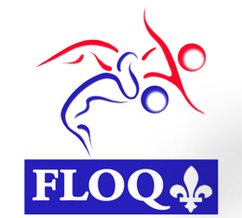

DONATION FORM –PLACEMENTS SPORTS PROGRAMME

 | Individual | Mr.  Ms. | First name |  | Last name

 | Company  Foundation | Name

Address _____________________________________________________________________________________

City _____________________________ Province ____________________ Postal Code _____________________

Phone __________________________________ Email __________________________________________________

One time donation | Monthly donation
Amount: $ | Amount: $
○ Cash
○ Cheque (Please make it payable to Sports Quebec and write down the federation you wish to support at the bottom of the cheque) | ○ Bank transfer  Bank name:  Institution number:  Transit number:  Account number:
○ Credit Card
Name on credit card ________________________________________________________________________________

Credit card number _______________________________________________ Exp. date. ______________________

Cardholder’s signature : ______________________________________________________________________

I acknowledge that this donation will not bring any direct or indirect benefit to me or any member of my family or to any person related to me in the sense of the fiscal laws. By signing below I confirm having accepted that my donation will go towards funding the operations of the Fédération de lutte olympique du Québec.

Signature ______________________________________ Date_____________________

A tax receipt will be issued for all gifts of $25 and more.
Any donation of $ 25 or more will also allow Fédération de lutte olympique du Québec to benefit from matching funds from the Placements Sports programme. For example, a donation of $100 will yield $360 to Fédération de lutte olympique du Québec.

Please send to: Ode Caron
Directrice, Placements Sports
et responsable du Fonds Sports-Quebec
4545, Pierre-De-Coubertin avenue
Montreal (Quebec) H1V 0B2

